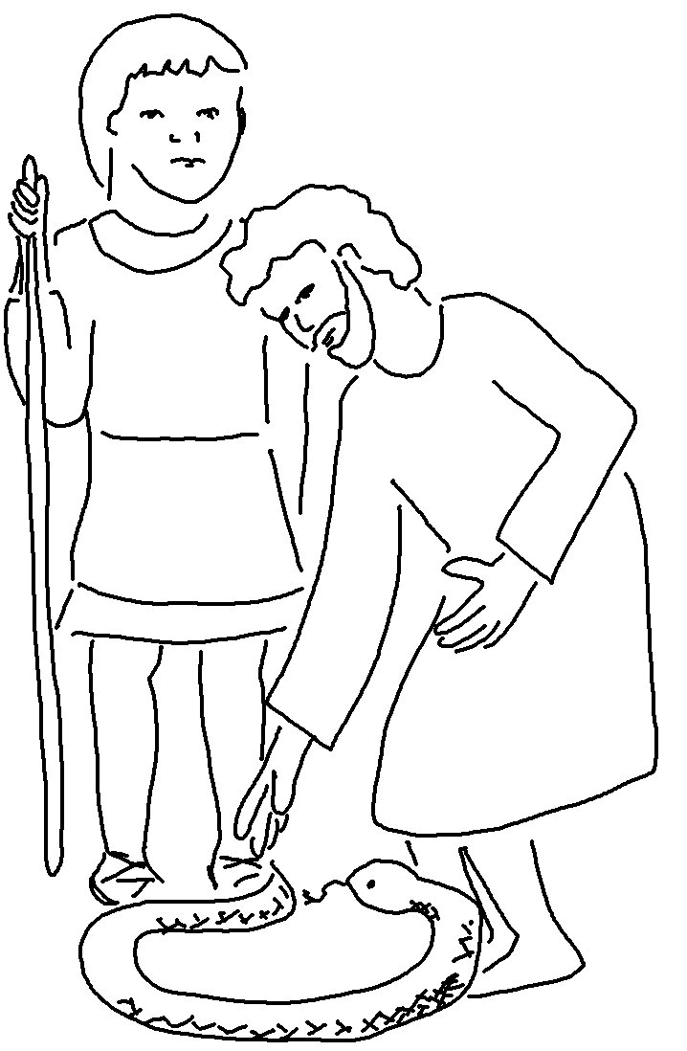
I will help you speak. Exodus 4:12_{NIV}

